**Power BI Project Report**

**ON**

**“**Netflix Movies & TV Shows**”**

**Description of Dataset:**

This report examines Netflix data through the use of a Power BI dashboard. The cast, country, added date, director, duration, listed in, rating, show ID, title, and type that are available on Netflix are all stored in the dashboard. The data's key insights, trends, and patterns are highlighted in the analysis to help people understand Netflix's content offerings better.

**Creation of Dashboard:**

The first step is to clean the dataset. This is performed by importing the dataset using the “Get data” option. Using the said option, we imported the “Netflix titles” CSV file. Then we selected the transform data option which led us to “Power Query Editor”. We replaced the blank cells present in different columns such as directors, casts, etc. with those not identified. We removed the column of description by selecting the description attribute and selecting the option of “remove column”. Some empty rows which were creating problems during the analysis were removed using the “remove rows” option, and the “remove blank rows” option was used.

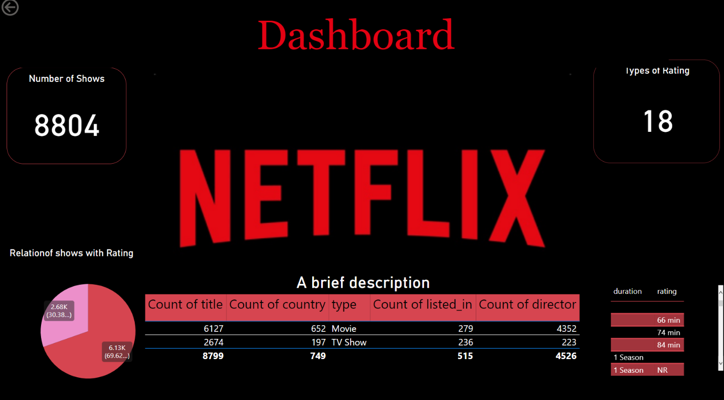

Different graphs were made using the visualization tab. These graphs include pie charts, bar graphs, waterfall charts, fill maps, cards, etc. These graphs were selected from the “visualization tab” and then fields were added to the graphs through the drag and drop method from the “data tab”.

The background of the dashboard was formatted using the option “canvas background” the image was added to it and “transparency” was reduced to zero percent. On other pages of the dashboard, the background color was changed to black. We also formatted these graphs. We selected these graphs one by one and then changed the background color of the graphs to black by going to the “general” and then “effects” options. Moreover, the text color was also changed by going to the visual option. The color of the text was also changed and the columns and rows were also formatted using the “visual” option in the visualization tab.

To connect these pages of the dashboard, we used the option of “drill through”. Some fields were added to the drill through so that one can move from one report to the other by clicking on the graphs and then selecting the report page they want to move towards.

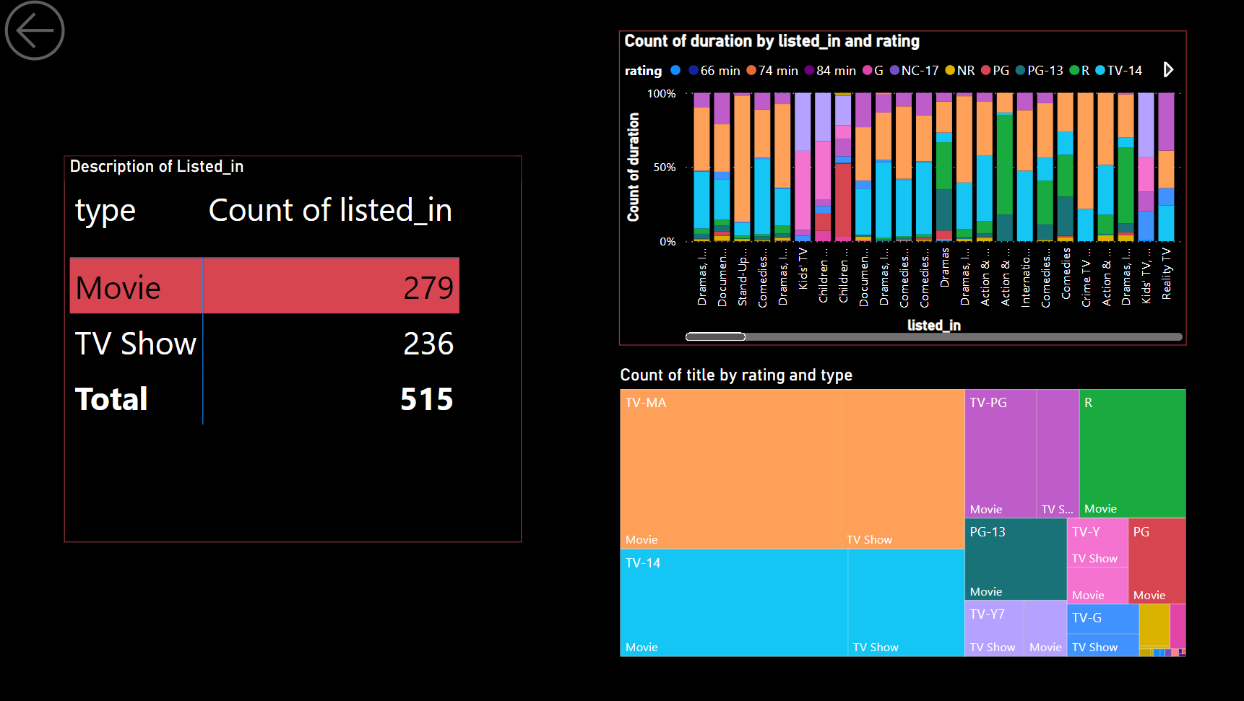

The graphs were adjusted by clicking and dragging it on the page to our liking. The arrows present at the top left corner are used to move from one page to the other. They work by clicking the arrow with the mouse and pressing the control button together.

**Analysis of the Graphs:**

The graph gives a brief breakdown of how Netflix distributes the lengths of movies and TV shows based on their rating and genre.

We have created a page representing all the basic information related to Movies in the dataset.

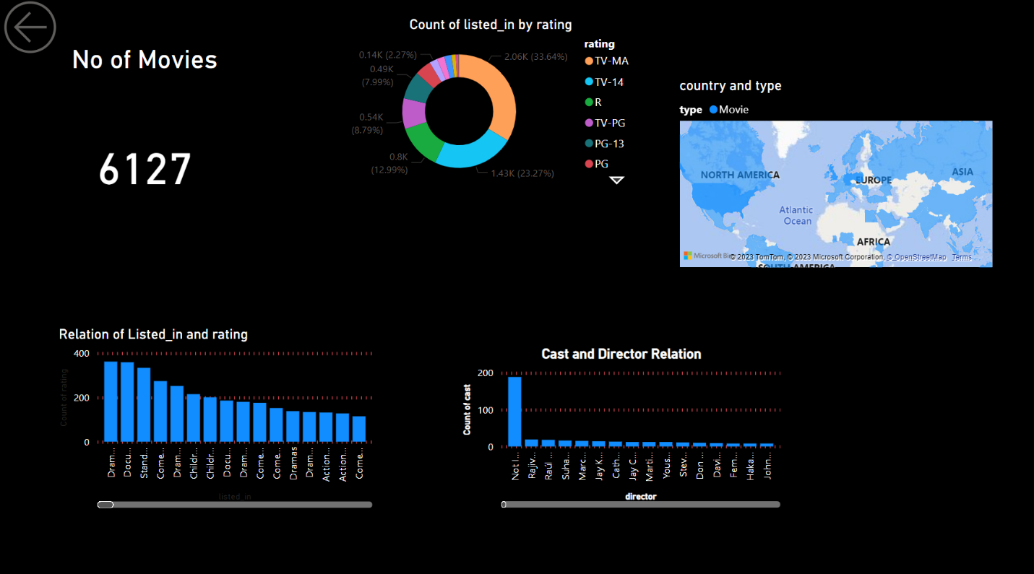

Then we created another page showing all trends of TV shows.

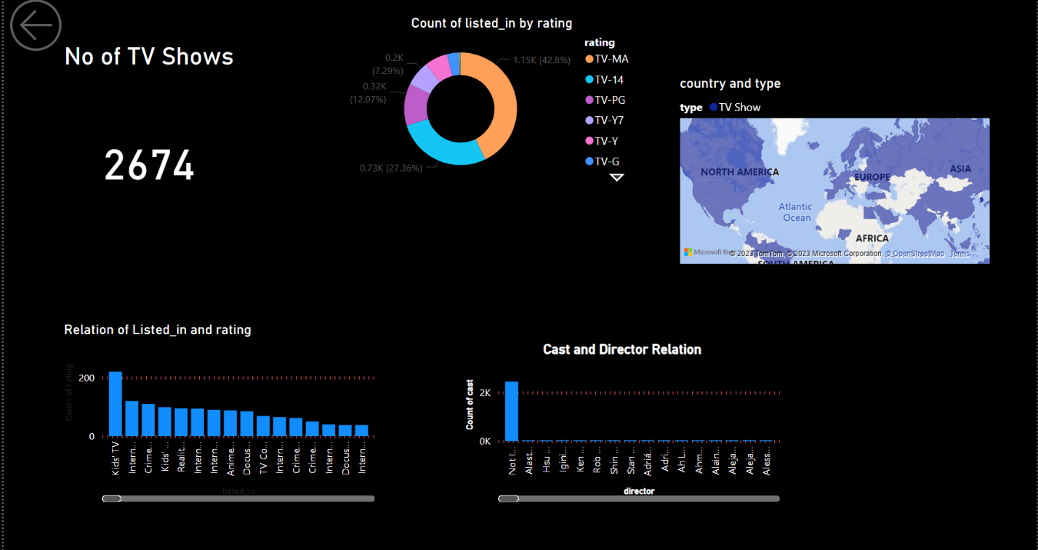

We may learn a lot about the trends and appeal of a particular material on the platform by examining the differences between the two.

A waterfall chart is a useful tool for illustrating how data changes over time. A waterfall chart for the Netflix dataset might be used to monitor changes in the number of ratings across various content categories and geographies.

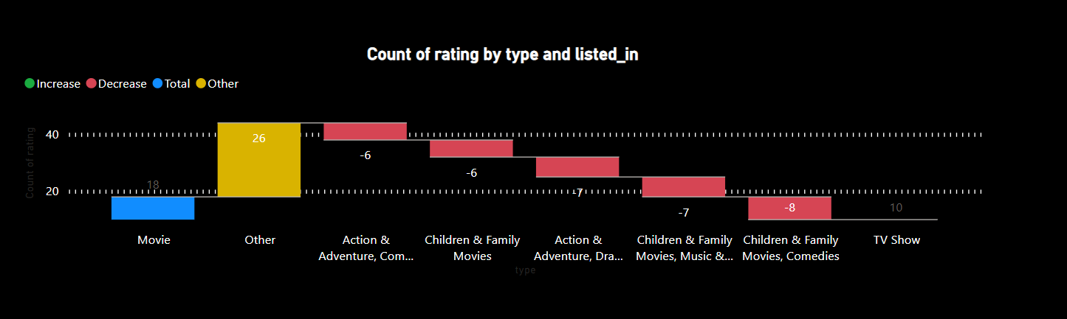

The filled map would be helpful in visualizing and examining the link between the number of movies and tv shows and ratings and the country to which they belong.

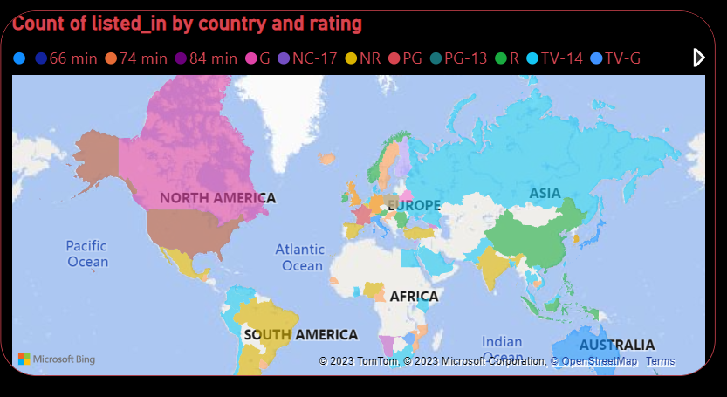

Pie charts are excellent for showing percentages or proportions of a whole. Using the "type" column to group them together, we have made a pie chart in the Netflix dataset to display the percentage of movies and TV series available on the service. We might be able to comprehend the popularity of various Netflix content kinds with the aid of this depiction.

By examining these graphs, we may identify any patterns or trends in the data, such as changes in the length of material over time, distinctions between movies and TV series, and any notable outliers.

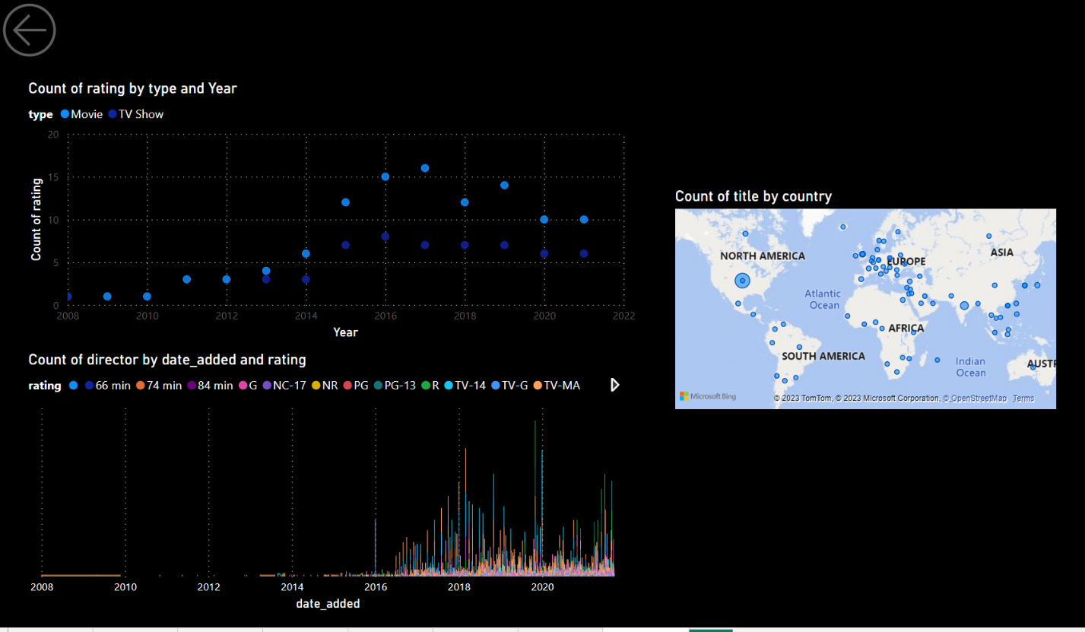

To conclude, this report helps you gain a better understanding of the content offerings of Netflix and use the insights to make informed decisions.